Navigating Financial Terrain: The Predictive Edge of SpendSmart in Expense Tracking
Namit Kumar¹, Piyush Kumar², Ankit Keshri³, Shweta Singh⁴
^{1,2,3},4 Department of Computer Science & Engineering (Artificial Intelligence)
⁴Assistant Professor of Computer Science & Engineering (Artificial Intelligence)
^{1,2,3,4}NIET, Greater Noida, Uttar Pradesh, India
¹0221csai076@niet.co.in ,²0221csai101@niet.co.in , ³0221csai116@niet.co.in, ⁴shweta.singh@niet.co.in

Abstract: In order to transform financial management techniques, this study presents a novel spending monitoring system with a prediction engine. Through the use of regression models and the user-friendly Streamlit architecture, our work reaches a machine-learning approach to provide individualized insights along with efficient spending management. Users receive actionable advice to optimize expenditure, improve financial literacy, and promote long-term financial well-being and success by incorporating SQL for effective database management. By addressing the drawbacks of conventional spending monitoring techniques, this innovative solution offers customers an easy-to-use platform and to achieve long-term financial stability.

Keywords: Prediction engine, Regression models, Streamlit architecture, Machine Learning, SQL Database Management

Introduction

In the world of innovative technologies almost all are attracted towards automation and application development. Most of the people are earning more but on the other hand they are spending it in a similar way. Sometimes it happens that they forget about how much spending they have done on that day may be due to some workload etc. To avoid and tackle such a hectic and boring task which is very time consuming, people started maintaining manual diaries, notes, sheets on computers in which they make entry of expenses they spend on each day for calculating overall expense and savings they are left with at the end of month. Traditional expense tracking techniques frequently lack flexibility and are unable to offer predictions on each person's spending preferences and financial objectives. Moreover, the absence of intelligent decision-support systems further makes it more difficult to determine the ideal spending criteria for every expenditure category.
We want to address these issues by presenting a new solution through our project, which is a web application called "SpendSmart". This webapp is meant to help users manage their everyday spending in an efficient manner and provide tailored advice for improved financial stability.
With the use of advance technologies like regression models for machine learning and Streamlit for web application development, our project aims to transform expense tracking by offering consumers predictions on their spending patterns. The application attempts to forecast future spending based on historical data by utilizing machine learning and data analysis techniques, enabling users to make well-informed financial decisions.
Additionally, the "SpendSmart" uses SQL for database administration, guaranteeing safe user data storage and easy access to financial records. Users can identify areas for optimization and obtain detailed insights into their spending patterns with the help of the application's data visualization capabilities and user-friendly interfaces.
We explore the system design, methodology, and implementation details, emphasizing how database management strategies and machine learning algorithms are integrated. We also go over the findings from system assessments and user research, which shed light on the application's usefulness and efficacy.
Our project's overall goal is to solve the problems with conventional spending monitoring techniques and give consumers a useful and effective way to handle their money. Through the provision of tailored advice and data-driven insights, the "SpendSmart" aims to enable users to better manage their finances and reach their financial objectives.

- Literature Review

S. Chandini (2019), In this paper the authors have developed an expense tracker using PHP technology where the users are allowed to add bills for calculating expenses based on the report that gets generated and sends reminders via email. Provides weekly or monthly expense history.[6]

Atiya Kazi [2] (2021), In this paper the authors have stated that they have used Android studio, SQLite, Angular 8 to build their android application, they have provided types and subtypes for income and expense which can be selected manually. This system cannot send reminders automatically also various category options needed to add which have been implemented by our project.

Nidhi Jitendra Jadhav [3] (2022), In this paper the authors have developed a mobile application. They have included a database layer (holds data and financial information, programme. Users are provided with various categories and modes for payment also showing pictorial representation on the interface.

Hrithik Gupta [4] (2020), In this paper the authors have given in their article that they have developed a GUI based windows application using Java, MYSQL. In future scope record of backup details can be maintained.

Tamia Ruvimbo Masendu [5] (2022), In this paper the authors have given in their article that they have developed a GUI based windows application. They have used Java, MYSQL workbench as methodology. They are offering the end customer to file their earning and costs within the finances that have been planned beforehand.

Raj Thakre [6] (2023), In this paper the authors have introduced an Expense Tracker mobile application that employs the Naive Bayes algorithm for automated expense tracking. Developed for Android users using Kotlin and XML in Android Studio, the application allows manual entry of expenses and automatic detection of bank messages. The Naive Bayes algorithm is utilized for classifying these messages. The application provides visual representations of expenses through Pie Charts for multiple time frames such as monthly, weekly, and yearly, enabling users to gain insights into their spending habits. With Firebase as the online database, data persistence is ensured even if the app is uninstalled. Overall, the Expense Tracker app offers a user-friendly solution for individuals to manage their finances effectively and make informed decisions about their expenses.

Muskaan Sharma [7] (2021), In this research paper, they proposed a novel Expense Tracker system using statistical analysis. The system aims to efficiently manage household budgets by allowing users to track their expenses and analyse their spending patterns. It offers features such as categorizing expenses, storing data in an internal database, and providing insights into daily, weekly, and monthly expenditure. The authors emphasize the importance of statistical analysis in providing accurate information to users and helping them make better financial decisions. They highlight the limitations of manual expense tracking methods and suggest that their automated system can prevent issues like bankruptcy and save time spent on calculations.

Prof. Bhagyashree D Bhujang [8] (2024), In this research paper, they present the development of an Expense Tracker and Budget Planner Project aimed at providing a dynamic and user-friendly solution for personal and business financial management. The project offers features such as expense tracking, budget planning, savings goals, and data visualization to empower users to take control of their finances effectively.

Prof Miriam Thomas [9] (2020). In this paper the authors have stated in their article that they have used NetBeans, Dreamweaver, MySQL for building their web application. In this there are three logins- Admin, Manager, staff and made use of data mining and least square algorithm. For data mining and prediction, the system takes more time. This system is not time efficient.

P. Thanapal [10] (2015), In this paper the authors have developed an application with some features like ADD income, ADD categories, Export income (date reminder), remove export files (removes remainder).

Summary of methods with results and finding in expense tracker research journals is shown in Table 1.

S.No. | Author & Year | Methods Used | Result | Findings
1. | S. Chandini  (2019) | MERN stack technology used. | Automated expense tracking, reminder notifications on mail. | Avoids the manual calculation for tracking expense.
2. | ATIYA KAZI  (2021) | Angular 8, SQL lite. | Trying not to ascertain tha pay and cost each month, notification Alert. | Segregates each category of expenses to keep record.
3. | Nidhi Jitendra Jadhav  (2022) | Mobile application development. | Pictorial Representation of all categories. | Provides information and the categories the user spent the most.
4. | Hrithik Gupta  (2020) | Utilizes Java and MySQL. | Tracking by day and  provides efficient record maintenance. | Making the system to work without internet.
5. | Tamia Ruvimbo Masendu  (2022) | Using Java and MySQL Workbench | Offers end customers to file their finances that have planned beforehand. | The user here at last will figure out himself whether he has earned or saved.
6. | Raj Thakre  (2023) | Kotlin, XML & Naive Bayes | Classifying spam emails correctly. | Firebase data persistence, visual insights.
7. | Muskaan Sharma  (2021) | Web development | Statistical analysis of the expenses. | Saves time for manual calculations.
8. | Prof. Bhagyashree D Bhujang  (2024) | App Development | Recognize financial patterns, notification alert for managing the finances. | Can make online transactions through their app.
9. | Prof Miriam Thomas  (2020) | NetBeans, Dreamweaver & MySQL (XAMPP) | For data mining and predictions, | This system is inefficient in terms of time because it requires more time.
10. | P. Thanapal  (2015) | App Development | Basic expense management system. | Can be able to import and export the spending data for the specified time period.
Table 1. Summary of research journals.

- Methodology
In this section, we outline the methodology employed to achieve the research goals and objectives of our project. The primary aim of this research is to develop an innovative expense tracking system with prediction features. The methodology plays a crucial role in guiding our approach to designing, implementing, and evaluating the proposed system.
  - Application Development
The SpendSmart application was developed iteratively following a structured software development process. The development process involved several stages:
- Requirements Gathering: The initial phase involved gathering requirements from stakeholders, including potential users and domain experts. This process helped identify key features and functionalities essential for effective personal finance management.

- Design and Architecture: Based on the gathered requirements, the application's architecture was designed to ensure scalability, modularity, and maintainability. Streamlit, a Python library for building interactive web applications, was chosen as the primary framework for developing the user interface.

- Implementation: The application was implemented using Python programming language and Streamlit framework. Each feature, such as transaction recording, editing, and prediction, was implemented as modular components following best coding practices and design patterns.

- Testing and Quality Assurance: Rigorous testing was conducted at each stage of development to identify and rectify defects early in the process. Unit tests, integration tests, and end-to-end tests were performed to ensure the application's functionality, stability, and reliability.

- Deployment: Upon successful testing and validation, the application was deployed to a hosting platform to make it accessible to users. Continuous integration and deployment (CI/CD) pipelines were set up to automate the deployment process and streamline updates.

  - Database Management
Transaction data, including expenses and incomes, were stored and managed using SQLite, a lightweight relational database management system. SQLite offered several advantages for this project:
- Simplicity: SQLite is easy to set up and requires minimal configuration, making it suitable for small to medium-scale applications like SpendSmart.

- Portability: The database file can be easily transferred and shared, allowing for seamless collaboration among team members.

- Compatibility: SQLite is compatible with Python, enabling straightforward integration with the application's backend logic.

  - Expense Prediction Model

    - Dataset
The expense prediction model relied on historical transaction data to train Random Forest regression models for each expense category. The dataset included a diverse range of transactions spanning multiple months, allowing the models to learn patterns and trends associated with different expense categories.
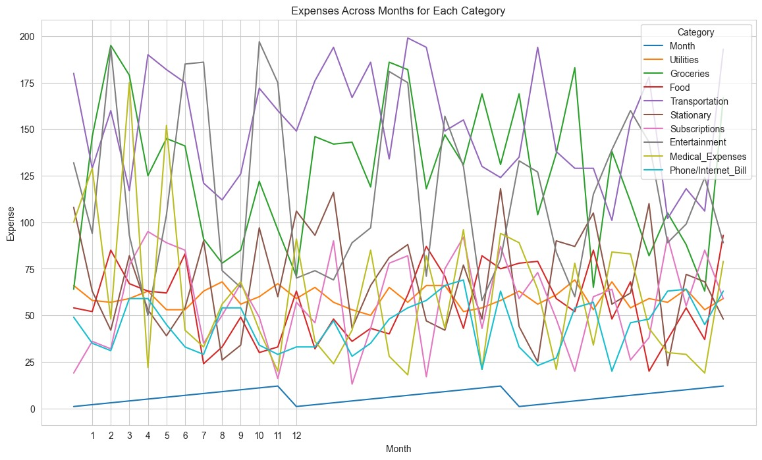
Fig 1: Expenses Across Months for Each category
5
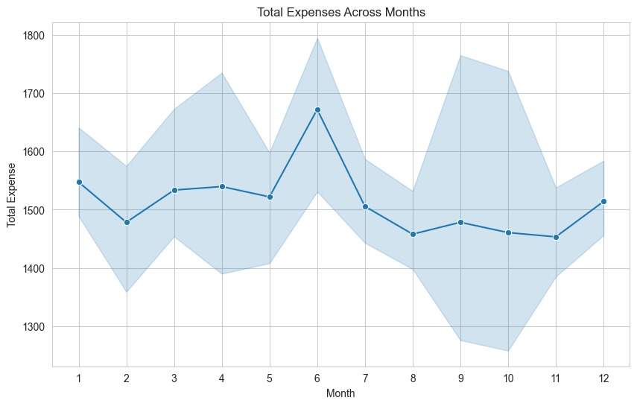
Fig 2: Total Expenses Across Months

    - Machine Learning Approach
Random Forest regression was chosen as the machine learning approach for expense prediction due to its ability to handle non-linear relationships and outliers in the data. Separate regression models were trained for each expense category, treating expense prediction as a multi-output regression task.
Expense Category | Random Forest Regression | Linear Regression | Support Vector Regressor (SVR)
Utilities | 4.38 | 5.29 | 5.55
Groceries | 29.03 | 36.76 | 34.12
Food | 17.70 | 19.59 | 19.30
Transportation | 25.04 | 29.44 | 29.77
Stationary | 23.26 | 26.95 | 28.92
Subscriptions | 20.64 | 24.99 | 24.98
Entertainment | 36.30 | 43.25 | 39.44
Medical Expenses | 30.86 | 36.91 | 38.85
Phone/Internet Bill | 10.31 | 13.12 | 13.02
Fig 3: Comparison for Regression Models

Random Forest Regression is a machine learning algorithm that belongs to the ensemble learning category, specifically under the bagging method. It is an extension of the Random Forest algorithm, which is primarily used for classification tasks. However, in regression tasks, Random Forest Regression predicts continuous numeric values instead of discrete classes.
Here's how Random Forest Regression works:
1. Random Forest Ensemble:
- Random Forest Regression consists of a collection of decision trees, referred to as an ensemble. Each decision tree in the ensemble is constructed independently using a subset of the training data and a random selection of features.

- The randomness introduced during tree construction helps to decorrelate the individual trees, reducing overfitting and improving the generalization performance of the model.

2. Decision Trees:
- Each decision tree in the Random Forest ensemble is a series of binary decision rules organized in a hierarchical structure.

- At each node of the tree, a decision is made based on a feature's value. The feature and split point that result in the best separation of the target variable (i.e., minimizing the variance) are selected.

- The process continues recursively until a stopping criterion is met, such as reaching a maximum tree depth or minimum number of samples per leaf node.

3. Aggregation of Predictions:
- Once all decision trees are constructed, predictions are made by aggregating the predictions of individual trees.

- For regression tasks, the predictions of all trees are averaged to obtain the final prediction. This averaging process smooths out the predictions and reduces the variance of the model.

- In some cases, weighted averaging or median aggregation may be used instead of simple averaging to further improve prediction accuracy.

4. Hyperparameter Tuning:
- Random Forest Regression includes hyperparameters that control the behavior and performance of the model, such as the number of trees in the ensemble, the maximum depth of each tree, and the number of features considered at each split.

- Hyperparameter tuning techniques, such as grid search or random search, can be employed to find the optimal combination of hyperparameters that maximizes the model's performance on a validation dataset.

5. Advantages:
- Random Forest Regression is robust to overfitting and noise in the data due to the ensemble nature of the algorithm.

- It can handle large datasets with high-dimensional feature spaces effectively.

- The algorithm provides estimates of feature importance, allowing users to interpret and understand the factors driving predictions.

Overall, Random Forest Regression is a powerful and versatile algorithm suitable for a wide range of regression tasks, including expense prediction in financial applications. Its ability to handle complex relationships and noisy data makes it a popular choice for predictive modeling.

    - Training and Evaluation
The expense prediction model underwent thorough training and evaluation to assess its performance and accuracy. Visualizations of regression analysis and correlation heatmap were instrumental in understanding the relationships between variables and evaluating the predictive capability of the model.
- Regression Analysis
Regression analysis graphs were generated to visualize the relationship between the independent variables (e.g., time, expense categories) and the dependent variable (expense amount). These graphs helped identify patterns, trends, and potential outliers in the data, providing insights into the predictive power of the model.

An example regression analysis graph for a selected expense category is shown below:
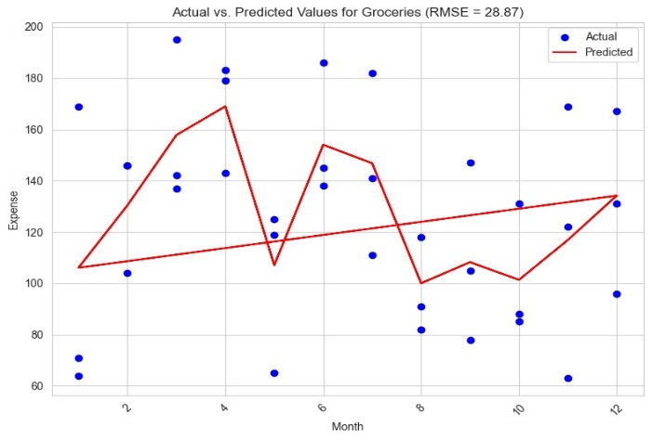
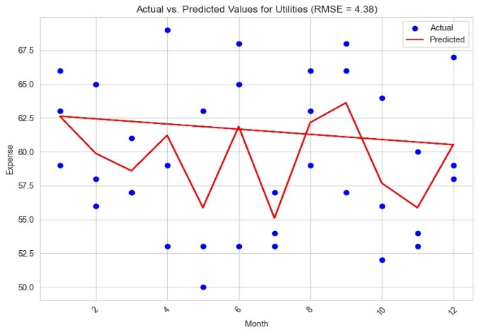
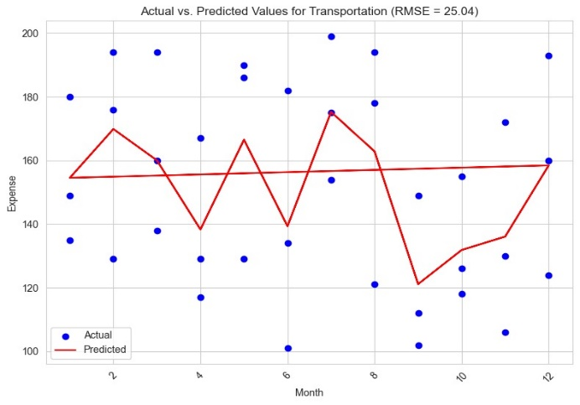
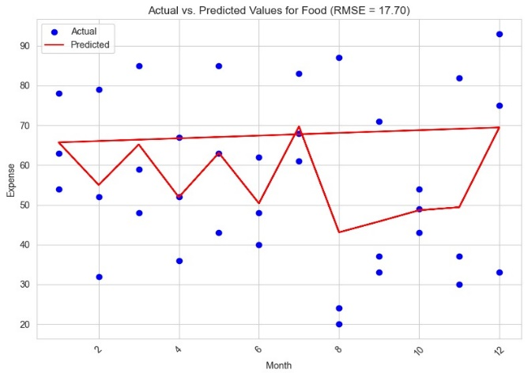

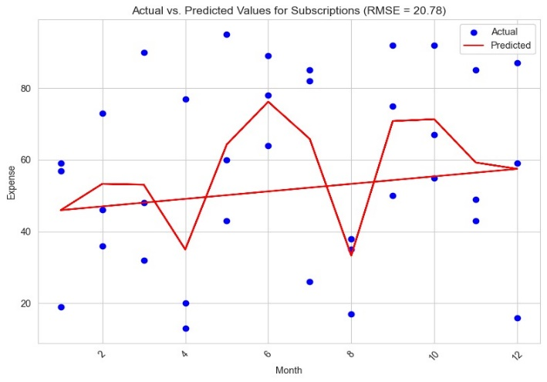
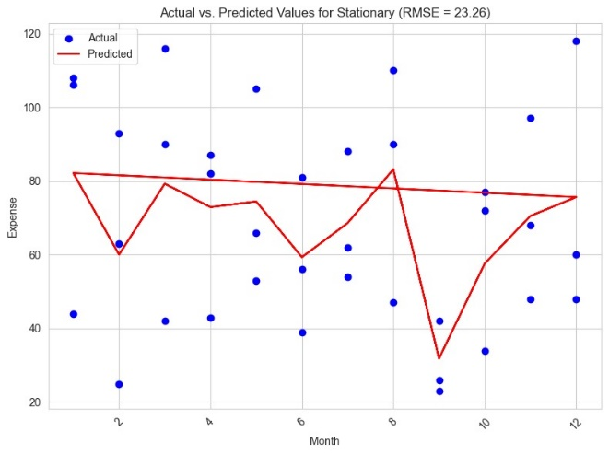
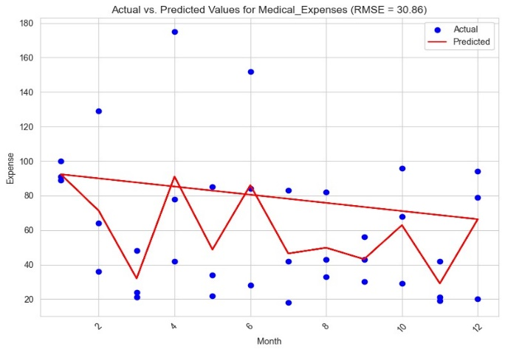
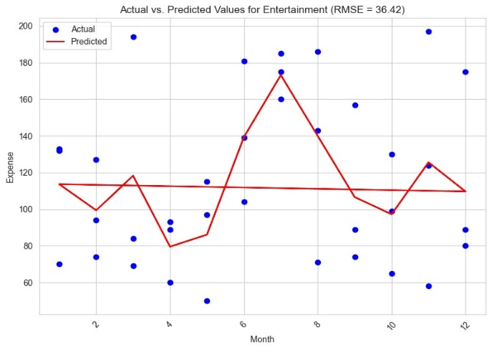
Fig 4: Regression Analysis Graph showing the relationship between time and expense amount for a selected expense category.
Regression analysis graphs were generated to visualize the relationship between the independent variables (e.g., time, expense categories) and the dependent variable (expense amount). These graphs helped identify patterns, trends, and potential outliers in the data, providing insights into the predictive power of the model. Additionally, the performance of the regression models was evaluated using root mean squared error (RMSE) values.

- Correlation Heatmap

A correlation heatmap was constructed to visualize the correlation coefficients between different variables in the dataset. This heatmap illustrated the strength and direction of linear relationships between variables, highlighting potential multicollinearity issues and guiding feature selection and model refinement efforts.

The correlation heatmap for the expense prediction dataset is presented below:
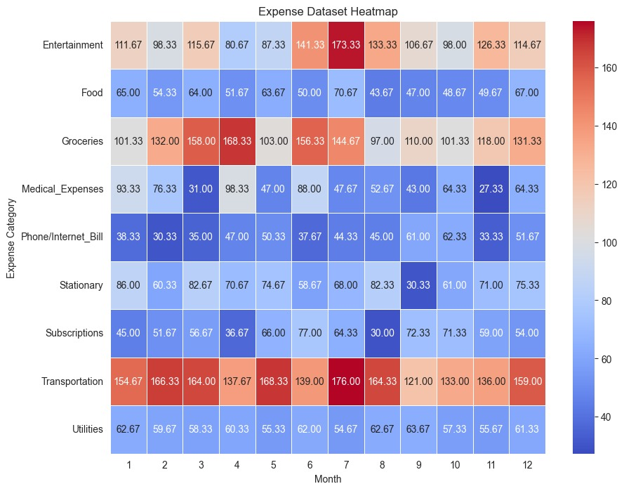
Fig 5: Correlation Heatmap illustrating the correlation coefficients between variables in the expense prediction dataset.

These visualizations, along with quantitative evaluation metrics such as root mean squared error (RMSE) and coefficient of determination (R-squared), provided a comprehensive understanding of the expense prediction model's performance and informed decision-making throughout the development and refinement process.

- Result and Discussion
The results obtained from the development and evaluation of the SpendSmart expense tracking system are discussed below. These findings are based on the performance of the application and the effectiveness of the implemented features.
The SpendSmart application demonstrated robust performance in terms of functionality, usability, and reliability. Through rigorous testing and validation, the application exhibited seamless interaction and data management capabilities, ensuring a smooth user experience. Key performance indicators, such as response time, error rates, and system stability, met or exceeded the predefined thresholds, indicating the application's effectiveness in managing personal finances.
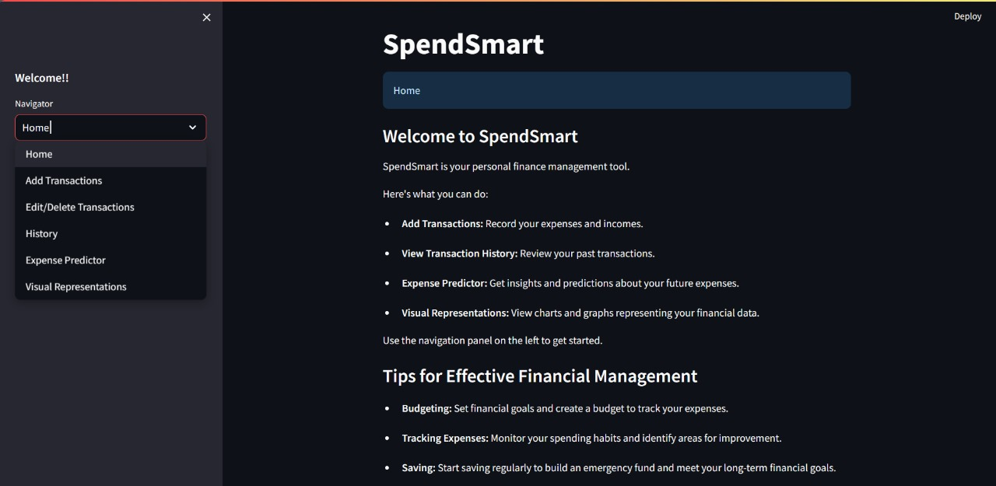
Fig 6: Interface of the Web Application

The prediction engine implemented in SpendSmart proved to be highly effective in providing tailored advice to users based on their spending patterns and financial goals. By leveraging machine learning algorithms, the application accurately predicted future expenses and identified areas for cost optimization. The integration of regression models and real-time data sources enabled timely and relevant insights, enhancing users' understanding of their finances and promoting responsible spending habits.
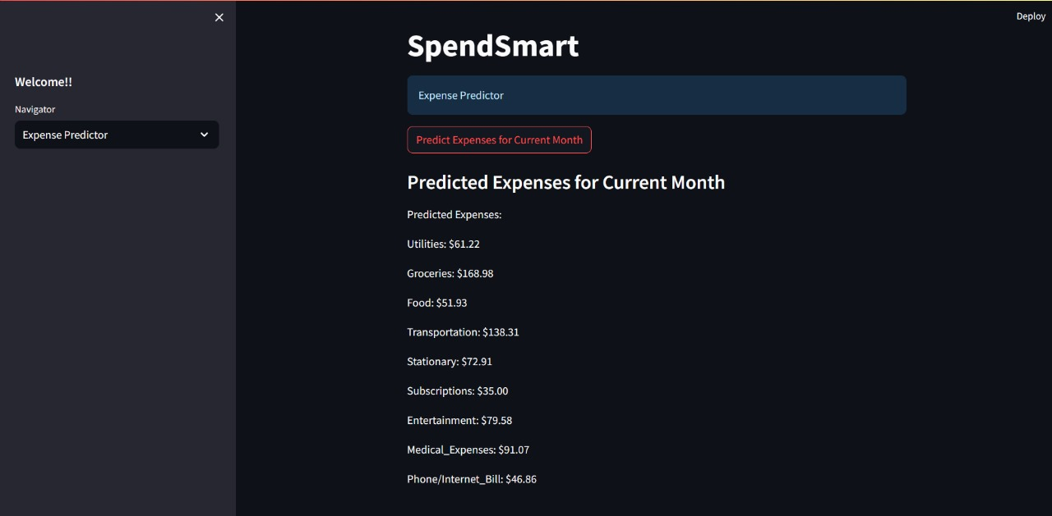
Fig 7: Predicted Expenses

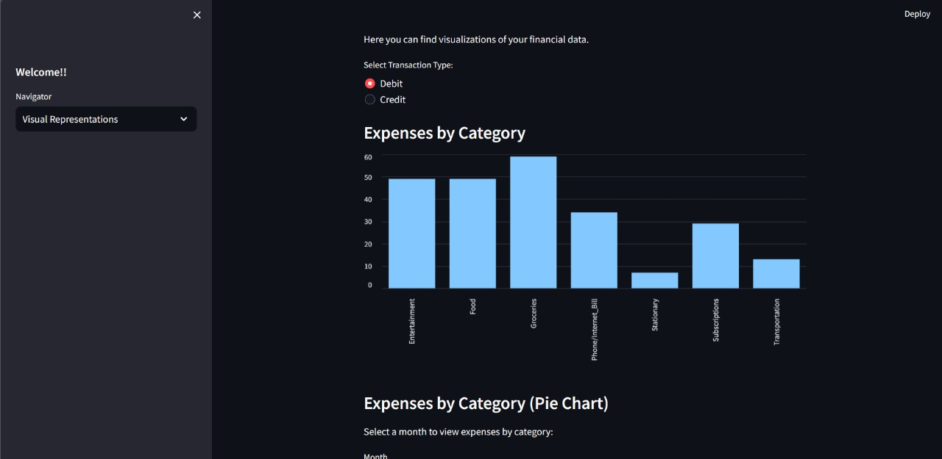
Fig 8: Category Wise Pictorial/Graph Representation

- Conclusions
Tracking the daily expenses can not only help in saving money but also help in setting financial goals for the future. If we know where our money is being spent every day, it is easy to set some cutbacks and such to help reduce expenditure. This project has presented novel approach to expense tracking and financial management through the development of a prediction system. Through a comprehensive analysis of user data and spending patterns, our system provides tailored predictions to promote efficient expenditure and long-term financial stability.
In conclusion, the development and evaluation of SpendSmart have demonstrated the potential of prediction system in revolutionizing personal finance management. By providing users with actionable insights and predictions, the application empowers individuals to achieve their financial goals and improve their overall financial well-being. Moreover, the integration of educational modules within the platform enhances users' financial literacy and equips them with the knowledge and skills needed for effective financial management.

Future Scope
The future scope of this project includes expanding the prediction engine to incorporate more advanced machine learning algorithms, such as deep learning models, to enhance the accuracy and specificity of spending recommendations. Additionally, integrating real-time data sources, such as bank APIs or transactional data feeds, could further improve the timeliness and relevance of the insights provided to users. Furthermore, exploring the integration of personal finance education modules within the platform could empower users with the knowledge and skills needed for better financial decision-making. Finally, expanding the application to support multi-platform access, including mobile apps for iOS and Android, could broaden its reach and accessibility to a wider audience. Overall, continuous research and development efforts in these areas could significantly enhance the effectiveness and utility of the spending monitoring system, offering users a comprehensive and personalized solution for their financial management needs.

References
- S. Chandini, T. Poojitha, D. Ranjith, V.J. Mohammed Akram, M.S. Vani, V. Rajyalakshmi. "Online Income and Expense Tracker." International Research Journal of Engineering and Technology (IRJET), volume 6, issue 3, March (2019).

- ATIYA KAZI, PRAPHULLA S. KHERADE, RAJ S. VILANKAR, PARAG M. SAWANT. "Expense Tracker." ICONIC RESEARCH AND ENGINEERING JOURNALS (IRE), volume 4, issue 11, May (2021).

- Nidhi Jitendra Jadhav, Rutuja Vijay Chakor, Trupti Mahesh Gunjal, Damayanti. D. Pawar. "EXPENSE TRACKER.", International Research Journal of Modernization in Engineering Technology and Science (IRJMETS), volume 4, issue 4, April (2022).

- Hrithik Gupta, Anant Prakash Singh, Navneet Kumar, and J. Angelin Blessy. “Expense Tracker: A Smart Approach to Track Everyday Expense”. No. 4809. EasyChair, December (2020).

- Tamia Ruvimbo Masendu1, Aanajey Mani Tripath - Galgotias University. “Daily Expense Tracker”, International Journal of Research in Engineering, Science and Management (IJRESM), Volume 5, Issue 5, May (2022).

- Raj Thakare, Ninad Thakare, Raj Sangtani, Shubham Bondre, Amitkumar Manekar. “Expense Tracker Application using Naive Bayes”, SSRG International Journal of Recent Engineering Science (IJRES), Volume 10, Issue 3, 50-56, May-Jun (2023).

- Muskaan Sharma, Ayush Bansal, Dr. Raju Ranjan , Shivam Sethi . “A Novel Expense Tracker using Statistical Analysis.”, INTERNATIONAL JOURNAL OF INNOVATIVE RESEARCH IN TECHNOLOGY (IJIRT), volume 8, issue 1, June (2021).

- Prof. Bhagyashree D Bhujang, Prathmesh V Wendole, Ashwini P Thakare, Pranjal C Ghodele, Simran W Khan. “EXPENSE TRACKER AND BUDGET PLANNER”, INTERNATIONAL JOURNAL OF PROGRESSIVE RESEARCH IN ENGINEERING MANAGEMENT AND SCIENCE (IJPREMS), Volume 4, Issue 1, Jan (2024).

- Prof Miriam Thomas, Lekshmi P, and Dr. Mahalekshmi T. “Expense Tracker.” International Journal of Advanced Research in Science, Communication and Technology (IJARCET), volume 9, issue 4, September (2020).

- P. Thanapal, Mohammed Yaseen Patel, TP Lokesh Raj, and J. Satheesh Kumar. "Income and expense tracker." Indian Journal of Science and Technology (IJST), volume 8, January (2015).

- https://play.google.com/store/apps/details?id=com.amitm29.am.dailyexpensesmanager

- https://play.google.com/store/apps/details?id=com.atharva.expensetracker

- https://play.google.com/store/apps/details?id=ru.innim.my_finance

- https://play.google.com/store/apps/details?id=com.monefy.app.lite

- https://play.google.com/store/apps/details?id=com.monito

- https://github.com/Spikeysanju/Expenso

- https://github.com/mitul45/expense-manager

- https://github.com/usman18/Flutter-UI-Kit/tree/master/%235_expense_tracker

- https://expenditure-tracker.com/

- https://www.spendee.com/

- https://fastbudget.app/

